14.74: a) The change is height 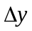is related to the displaced volume 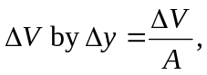 where A is the surface area of the water in the lock. 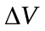 is the volume of water that has the same weight as the metal, so

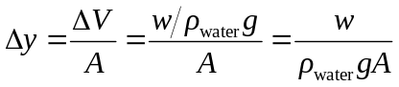
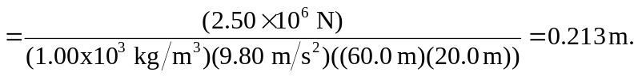

b) In this case, is the volume of the metal; in the above expression, 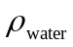 is replaced by 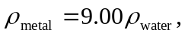 which gives 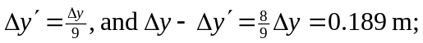the water sinks by this amount.

